**Year 3 Writing Expectations-** including all KS1 expectations

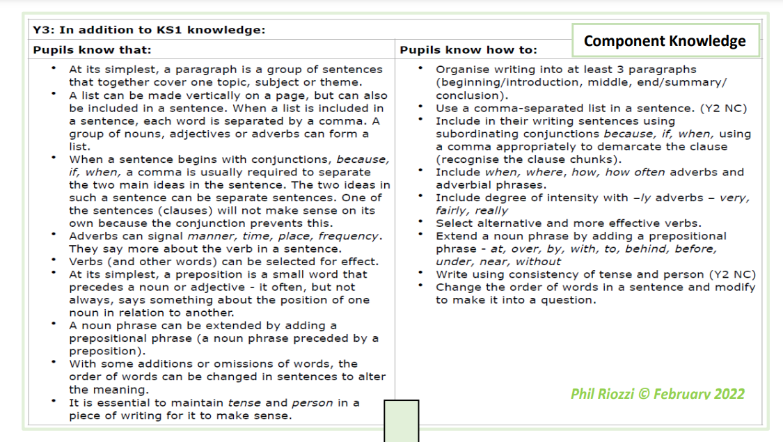

|  |
| --- |
| **Letter Formation** |
| **Children know how to:**   * Increase the legibility, consistency and quality of handwriting, e.g.: by ensuring that down strokes of letters are parallel and equidistant; * lines of writing are spaced sufficiently so that the ascenders and descenders of letters do not touch. |
| **Planning, drafting and Editing** |
| **In addition to KS1 knowledge, children know how to:**   * use ideas from their own reading and modelled examples to plan their writing. * begin to proofread their own and others’ work to check for errors (with increasing accuracy) and to make improvements –purple editing pens used regularly to edit and improve * organise their writing into more detailed paragraphs around a theme (e.g. beyond 3 paragraphs – beginning middle and end). |

|  |
| --- |
| **Audience, Purpose and Structure** |
| **In addition to KS1 knowledge, children know how to:**   * demonstrate an * increasing understanding of purpose and audience * by discussing writing similar to that which they are planning to write in order to understand and learn from its structure, vocabulary and grammar. * use the structure of a wider range of text types (including the use of simple layout devices in non-fiction). * make deliberate, ambitious word choices to add detail. * create settings, characters and plot in narratives. * begin to use dialogue to convey a character. |
| **Sentence Structure (Including punctuation and grammar)** |
| * maintain the correct tense (including the present perfect tense) throughout a piece of writing with accurate subject/verb agreement. * use ‘a’ or ‘an’ correctly throughout a piece of writing. * use simple conjunctions confidently and accurately. * use subordinate clauses, extending the range of sentences with more than one clause by using a wider range of conjunctions, including when, if, because, and although. * use a range of conjunctions, adverbs and prepositions to show time, place and cause. * use the full range of punctuation from previous year groups. * Punctuate direct speech (using inverted commas) |
| **Grammar Terminology** |
| **Recognise and use the terms:**   * Preposition * Prefix * Clause * Subordinate clause * Direct speech * Inverted commas (speech marks) * Ellipsis * Bullet point |
| **Phonic & Whole word spelling** |
| * To spell words with the / eɪ/ sound spelt ‘ei’, ‘eigh’, or ‘ey’ (e.g. vein, weigh, eight, neighbour, they, obey). * To spell words with the /ɪ/ sound spelt ‘y’ in a position other than at the end of words (e.g. mystery, gym). To spell words with a /k/ sound spelt with ‘ch’ (e.g. scheme, chorus, chemist, echo, character). * To spell words ending in the /g/ sound spelt ‘gue’ and the /k/ sound spelt ‘que’ (e.g. league, tongue, antique, unique). * To spell words with a / sh/ sound spelt with ‘ch’ (e.g. chef, chalet, machine, brochure). * To spell words with a short /u/ sound spelt with ‘ou’ (e.g. young, touch, double, trouble, country). * To spell words ending with the /zher/ sound spelt with ‘sure’ (e.g. measure, treasure, pleasure, enclosure). * To spell words ending with the /cher/ sound spelt with ‘ture’ (e.g. creature, furniture, picture, nature, adventure). |
| **Common Exception words** |
| * To spell many of the Y3 and Y4 statutory spelling words correctly. |
| **Prefixes and Suffixes** |
| * To spell most words with the prefixes dis-, mis-, bi-, re- and de- correctly (e.g. disobey, mistreat, bicycle, reapply, defuse). * To spell most words with the suffix -ly with no change to the root word; root words that end in ‘le’,‘al’ or ‘ic’ and the exceptions to the rules. * To spell words with added suffixes beginning with a vowel (-er/-ed/- ing) to words with more than one syllable (unstressed last syllable, e.g. limiting offering). * To spell words with added suffixes beginning with a vowel (-er/-ed/- en/-ing) to words with more than one syllable (stressed last syllable, e.g. forgotten beginning). |
| **Further Spelling Conventions** |
| * To spell some more complex homophones and near-homophones, including here/hear, brake/break and mail/ male. * To use the first two or three letters of a word to check its spelling in a dictionary |
| **Contexts (purpose) for Writing** |
| Writing to express and justify an opinion (History).  Narrative (Eyewitness account, Description, Science –Fiction story).  Poetry (Based on RE learning).  Scientific report.  Diary entry (Science).  Persuasive letter (Geography).  Persuasive advert (History).  Instructions (Science).  Informative writing (Fact file based on Geography). |