

Collaton St. Mary
Year 1 Long Term Planner

Autumn 1 |  |  |  | Autumn 2 |  |  | Spring 1 |  |  | Spring 2 |  |  |  | Summer 1 |  | Summer 2
Citizenship   |  |  |  | Explorers   |  |  | Leadership   |  |  | Expression   |  |  |  | Flourishing   |  | Citizenship  
Year Group Key Knowledge and Skills
PSHE | Art/Poetry | RE | History | Science | Narrative | RE/Music | Geography | History | DT | Music | Narrative | Science | Art |  | Narrative |  | DT | Geography | Science
Show an understanding of compassion | Drawing and Painting | Harvest | Changes in my life | Seasonal Changes | Story | Christmas | My locality | Lives of others | Design |  | Story | Living Things | Sculpture |  | KS1 Narrative |  | Measuring and weighing | Another Locality | Materials
Enquiry Question
Have you filled a bucket today? | How does Mrs Richards inspire me to be an artist? | Why should we celebrate Harvest? | How have things changed in my life? | How does the view outside my window change throughout the year? | Can I use conjunctions to extend my sentences? | Why does Christmas matter to Christians? | How can a map help us explore our local area? | Why should we remember Queen Elizabeth II? | Can I design a toy that works? | Can we make the sounds of the seasons? | How can adjectives improve a Wanted Poster? | How do plants survive and thrive? | How can I join and shape materials to make a sculpture? |  | How can editing improve my storytelling? |  | Why is weighing and measuring ingredients important? | How is Paignton different to Plymouth? | Which material should the Billy Goats Gruff use to make their bridge?
Metacognitive Tool
Creativity  Spider Diagram  Pictorial Ideas  Plan, do review |  |  |  | Independence  Good/Bad Plan  Pictorial Planning |  |  | Collaboration  Circle Map  Critique Stems |  |  | Independence  Bubble Map  Good/Bad Plan |  |  |  | Creativity  Ladder Ranking  Plan, do review  Spider Diagram |  | Collaboration  Circle Map  Critique Stems
 | Writing Genre
Class Charter  (Teacher/Eachother) | Poem to inspire  (Mrs Richards) | Information text to inform | Timeline  (A friend) | Performance with Reception children to explain | Narrative to entertain  (Another Class) | Poem and Nativity Performance to entertain (to parents) | Keys and Symbols to inform  (Friend) | Fact file to inspire  (Another class) | Review to evaluate  (Parents) | Reflection to express feelings | Narrative to entertain | Leaflet to explain  (Parents) | Evaluation to reflect |  | Narrative to entertain | Instructions  (Recipe)  to inform |  | Letter to inspire  (Parents) | Science Report to explain
 | Class Novel / Super Six
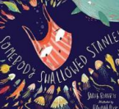  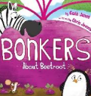  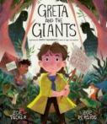  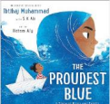  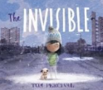  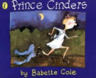 |  |  |  | 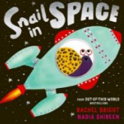  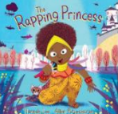  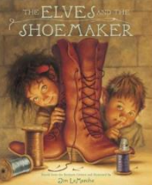  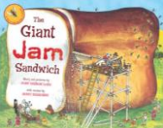  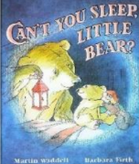  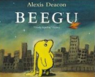 |  |  | 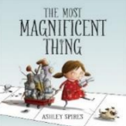  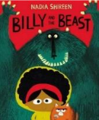  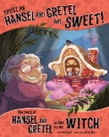  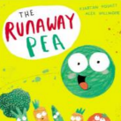  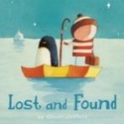  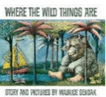 |  |  | 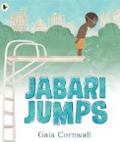  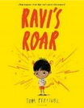  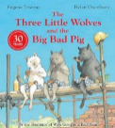  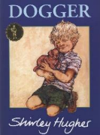  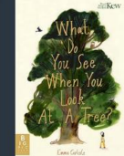  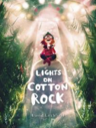 |  |  |  | 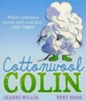  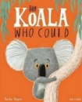  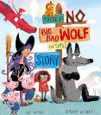  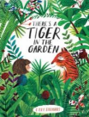  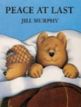  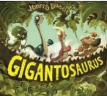 |  | 