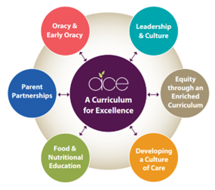
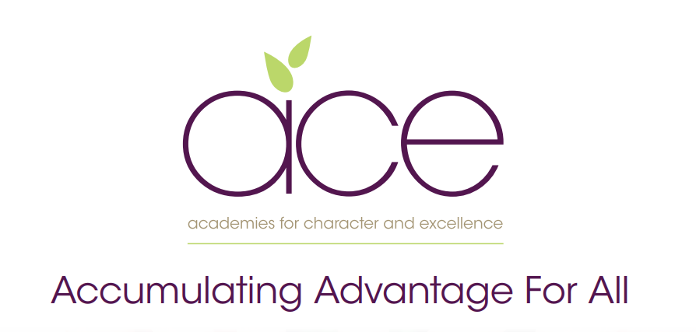

Collaton St Mary Primary School
Pupil premium strategy statement
2021–2024

This statement details our school’s use of pupil premium (and recovery premium for the 2021 to 2022 academic year) funding to help improve the attainment of our disadvantaged pupils.
It outlines our pupil premium strategy, how we intend to spend the funding in this academic year and the effect that last year’s spending of pupil premium had within our school.

School overview

Detail | Data
School name | Collaton St Mary Primary School
Number of pupils in school | 210
Proportion (%) of pupil premium eligible pupils | 25%
Academic year/years that our current pupil premium strategy plan covers (3 year plans are recommended) | 2021 - 2024
Date this statement was published | November 2023
Date on which it will be reviewed | October 2024
Statement authorised by | Local Governing Body
Pupil premium lead | Nicky Postlethwaite,  Headteacher
Governor / Trustee lead | Di Hatherley

Funding overview

Detail |  | Amount
Pupil premium funding allocation this academic year | £64,560 2023- £68, 385
Recovery premium funding allocation this academic year | £0
Pupil premium funding carried forward from previous years (enter £0 if not applicable) | £0
Total budget for this academic year  If your school is an academy in a trust that pools this funding, state the amount available to your school this academic year | £64,560 2023- £68, 385

Part A: Pupil premium strategy plan

- See our Trust wide plan ‘Accumulating Advantage for all’
In a changing world we recognise the need to ensure that our curriculum reflects how pupils are supported and encouraged to flourish in all aspects of their lives. Current research shows that the South West is one of the most challenging areas to grow up poor. We strongly believe that as a Trust, and through our curriculum, we are able to narrow the disadvantaged gap, supporting all pupils.

Our aims for our disadvantaged pupils

- Our aim as a Trust is to ensure that all pupils accumulate advantage, based on the high quality experience that we offer them through our curriculum and enquiry-based approach to learning.

- Our curriculum is rich and ambitious and offers all pupils an equal opportunity to experience a range of outdoor lessons, take part in educational visits, theatre trips, hands-on days, expert visits and have the opportunity to explore a wide range of extra-curricular clubs.

- We believe that all pupils should have the opportunity to aspire to be the best version of themselves. Therefore, we provide pupils with the experiences that develop their love of learning and support them to acquire experiences as they move through their school lives, to make informed choices when deciding future decisions.

Statement of Intent

At the heart of our curriculum lie three core values: pursuit of academic excellence; the explicit teaching of learning to learn, which includes the development of metacognition; and crucially, character education. We believe that through our curriculum and core principles we can ensure that our very high expectations result in improved outcomes for disadvantaged pupils. This ensures all children will achieve and flourish whilst acquiring life-long skills that enable learners to overcome any barriers to learning and future successes.

Objectives for our disadvantaged pupils

- We will ensure that the progress of our disadvantaged children will equal or exceed the progress of those who are not disadvantaged by implementing our strategy plan. The ACE curriculum plays a central and critical role in accumulating advantage for all pupils, including those that are presently or experiencing or have experienced disadvantage.

- All disadvantaged pupils will be equipped, academically, socially, culturally and emotionally to continue to make progress at their Secondary schools and beyond. Our aim is to ensure that all children leaving our schools are successful learners, curious explorers and healthy thinkers.

Our current pupil premium plan focuses on the following goals (see ‘Accumulating advantage for all’ booklet for more detail)

Strong leadership that drives:
- Equity through an enriched curriculum (including high-quality, well-researched and impactful interventions)
- A culture of high quality care
- Food and nutritional education
- Effective parent/carer partnerships
- Development of early oracy and ongoing oracy skills

Challenges

This details the key challenges to achievement that we have identified among our disadvantaged pupils.
Challenge number | Detail of challenge
1 | Many children have weak oral language skills on entry, including limited vocabulary, affecting their spoken language, comprehension and, later, their writing.
2 | Covid-19 lockdowns negatively affected children’s knowledge and skills in English and mathematics (lost learning) and exacerbated existing difficulties.
3 | For some children, their social, emotional and mental health (SEMH) needs negatively affect their learning.
4 | Some children lack resilience for learning and, during Covid-19 lockdowns, lost the resilience they had gained.
5 | Lack of parental support and their lack of knowledge about how to provide such support for their children are barriers to the progress of some children.
6 | Poor attendance and punctuality are barriers for some children.

Intended outcomes - see ‘Accumulating Advantage for all’

Intended outcome | Success criteria
- A Curriculum for Excellence  The ACE curriculum is ensuring QFT is making a difference for our disadvantaged pupils and progress measures show the gap between disadvantaged and others is closing | - As a result of careful and focused monitoring our PP pupils are becoming successful learners  - Journals reflect progress made in all three areas- metacognition, character education and academic excellence (see individual PP tracker)  - The progress of disadvantaged pupils is at least the same as the progress of non-disadvantaged pupils and no greater than a 10% difference by the end of KS2
- Oracy  All disadvantaged pupils have improved oracy skills and are increasingly able to communicate effectively | - Language link programme demonstrates improved language skills  - Oracy approach (across the curriculum) is evident in terms of key outcomes for pupils  - Mathematical talk (PDM 3.10.22) and maths leader coaching sessions have clear impact on outcomes  - PP children are read with daily, prioritised by class teachers and TA’s. - Pre-teach of vocabulary is introduced to children and explained prior to provide more opportunities for children to be successful. - Vocabulary is explicitly taught through quality first teaching and is planned for by class teachers. All classes regularly using the ‘remote control’ cards’
- Enrichment opportunities are providing pupils with the skills and knowledge to become more successful learners | - Take up of ASCs is high and pupils are clearly gaining through these experiences  - All disadvantaged pupils attend residentials and trips.
- High quality care through SEMH support is ensuring excellent wellbeing and readiness for learning | - Pupil outcomes have improved in all areas (academically, socially, emotionally, culturally)  - Pastoral support is well matched to individual need
- Food and Nutrition  Pupils and families have opportunities in school to participate in workshops and clubs to improve health through food and nutrition education | - All PP children have the opportunity to attend cookery club  - Families invited to a ‘family bake’ session to celebrate the course and grow the club  - PP children are well fed in school, they have good access to food and being hungry is never an issue – nurture group leads to monitor and check in
- Parent/carer partnerships are strong and parents are increasingly able to support their children’s well being and learning | - Improve attendance of disadvantaged pupils to 95%

Activity in this academic year

Teaching (for example, CPD, recruitment and retention)
Budgeted cost: £22,570
Activity | Evidence that supports this approach | Challenge number(s) addressed
Training to develop talk in the Early Years (speech and language) | Early Reading framework – Section 2: developing Talk and Appendix 2 | 1,4
Training for new staff members on how to deliver Language Link system (Speech and Language) | EEF – Oral Language Interventions | 1
Training for all staff to deliver RWI Phonics | Implementing a systematic programme (ERF) | 1
Coaching of phonic group staff by Reading Lead | Early Reading Framework – Section 5: Building a team of experts | 1,2
Weekly coaching and training to develop teaching staff’s pedagogy with a focus on assessment for learning. | EEF – Embedding Formative Assessment  EEF – Metacognition | 1,2,3,4
1:1 coaching for Early Career Teachers and new to trust teachers with SLT. | Strand 8 Professional Behaviours | 2,3
Maintaining Reception class as a single-age class.  - Targeted intervention for PP children to fill gaps.  Smaller phonics groups for targeted phonics support. | EEF- Targeted Academic Support | 1,2
Targeted Academic Support – small group intervention 2 x per week. | EEF- Targeted Academic Support | 1,2

Targeted academic support (for example, tutoring, one-to-one support structured interventions)

Budgeted cost: £ 22,525
Activity | Evidence that supports this approach | Challenge number(s) addressed
1:1 phonics tutoring | EEF – one to one tutoring | 1,2
1:1 fluency intervention | EEF – improving literacy at KS2 | 2
Classes are split to allow targeted PP intervention and physical education. | EEF – one to one tutoring  EEF – Physical Activity | 1,2
SENCO plans targeted support plans for individual PP pupils delivered by support staff. | EEF – Follow the Asses, Plan, Do, Review process | 1,2,3
Teachers prioritise pre-teaching for most disadvantaged pupils | EEF – one to one tutoring | 1,2

Wider strategies (for example, related to attendance, behaviour, wellbeing)
Budgeted cost: £ 21,690
Activity | Evidence that supports this approach | Challenge number(s) addressed
Deliver high-quality physical education to support mental and physical well-being | EEF – Physical Activity & Self-regulation | 2,4
Safeguarding lead to support families with parenting support, workshops, EWO support and Early Help. | EEF – parental engagement | 4,5,6
Boxall profile training and application | EEF – behaviour interventions | 3,4,6
SEMH interventions and brain breaks | EEF - Self Regulation
Breakfast At school runs daily for most disadvantaged for time to talk and food. | EEF – Magic Breakfast Club | 4,6

Total budgeted cost: £64,560

Part B: Review of outcomes in the previous academic year - Pupil premium strategy outcomes

Findings relating to our disadvantaged pupils were as follows:
- End of KS2 results show 75% (3 of 4) disadvantage pupils achieved ARE combined in reading, writing and maths. In reading, 75% of disadvantage pupils achieved Greater Depth, a higher percentage compared to non-disadvantage.

EYFS
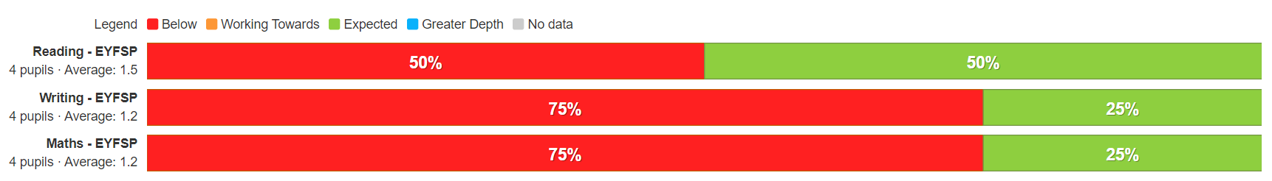

Year 1
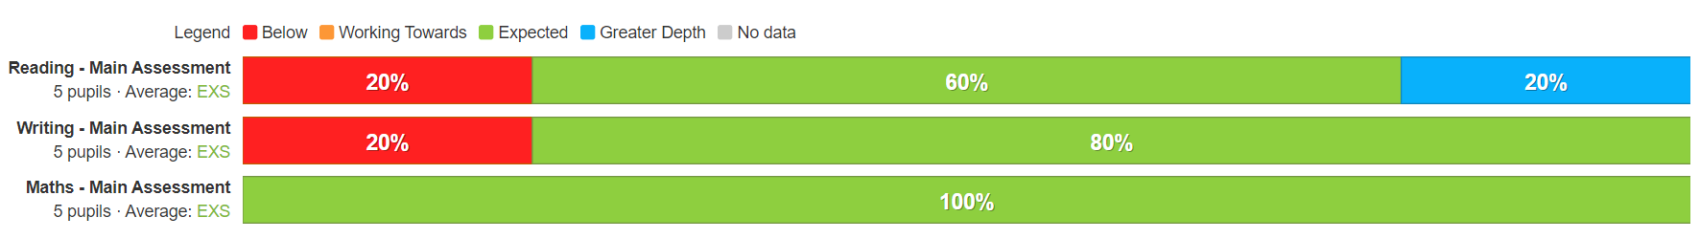

Year 2

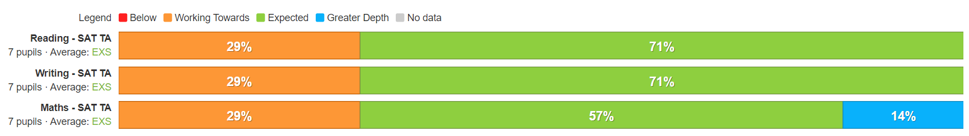

Year 3

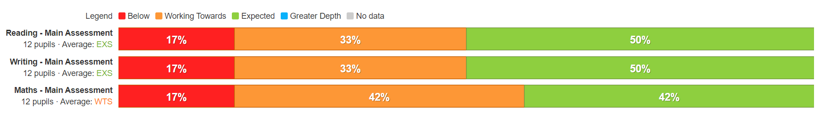
Year 4
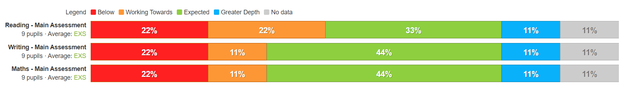

Year 5
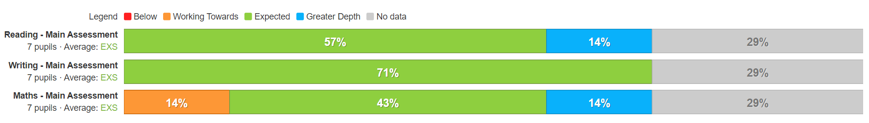

Year 6

- Targeted approach had the greatest impact: small group work before and after school, split classes using the PE teacher, and 1:1 tutoring sessions.
- Family and pupil surveys show that they feel safe, supported and happy with the school’s offer.

The findings confirm the positive direction of our current three-year strategy. As a result, we are investing further in 1:1/small-group interventions, before and after school, and in the school holidays. A key focus will be on improving attendance through a whole-school systematic approach.

Intended outcome | Success criteria | 21/22 | 22/23 | 23/24
The ACE curriculum is ensuring QFT is making a difference for our disadvantaged pupils and progress measures show the gap between disadvantaged and others is closing | As a result of careful and focused monitoring our pupils are becoming successful learners (see ACE SL outcomes)
 | Journals reflect progress made in all three areas- metacognition, character education and academic excellence (see individual PP tracker)
 | The progress of disadvantaged pupils is at least the same as the progress of non-disadvantaged pupils and no greater than a 10% difference by the end of KS2 for reading
Oracy  All disadvantaged pupils have improved oracy skills and are increasingly able to communicate effectively | Mathematical talk (fast five) and maths leader onging coaching sessions are improving fluency and mathematical understanding of concepts, this is impacting positively on outcomes.
 | Our reading strategy is ensuring that by the time children reach Y6 all children are at least at the expected standard
 | Pre-teach of vocabulary is introduced to children and explained prior to lesson, this provides more opportunities for children to be successful in the lesson
 | Vocabulary is explicitly taught through quality first teaching and is planned for by class teachers in all subjects. All teachers using ‘remote control’ cards.
 | Our oracy approach (across the curriculum) is evident in terms of key outcomes for pupils.
 | Language link programme demonstrates improved language skills for all pupils taking part in interventions
Enrichment opportunities are providing pupils with the skills and knowledge to become more successful learners | Take up of ASCs is high and pupils are clearly gaining through these experiences
 | The school seeks meaningful opportunities to broaden pupils horizons eg visiting authors, musical workshops and innovative subject days at our local Secondary schools. This is raising aspirations for children and providing enriching experiences
 | All disadvantaged pupils attend residentials, which are partly funded by the school. Pupils participate in a wider range of sports, team games and develop ACE character traits.
High quality care through SEMH support is ensuring excellent wellbeing and readiness for learning | Pupil outcomes have improved in all areas (academically, socially, emotionally, culturally) as a result of our nurture support and bespoke interventions
 | Pastoral support is well matched to individual need.
 | Wellbeing warriors are carefully selected so that their training and support of other learners positively impacts on their own well being
Food and Nutrition  Pupils and families have opportunities in school to participate in workshops and clubs to improve health through food and nutrition education | All children in receipt of PP are given the opportunity to attend our cookery club. Families invited to a ‘family bake’ session to celebrate the course and grow the club.
 | Children take part in food technology sessions where they develop their cooking skills. Outcomes are shared with families and healthier eating options are explored and adopted by families.
 | All children have access to high quality food throughout the school day, being hungry in school is never an issue.
Parent/carer partnerships are strong and parents are increasingly able to support their children’s well being and learning | Improve attendance of disadvantaged pupils to 95%.
Intended outcome | Success criteria | RAG | RAG | RAG

